

Power isn’t an equalizer
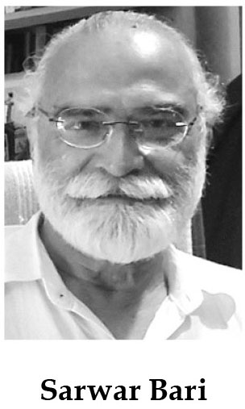
Power abhors sharing unless it is forced by emerging dynamics. Appearance and disappearance of local governance in Pakistan provides a best-case study in this regard.
Dictators hated elected assemblies but loved local governance because it would serve their interest well. On the other hand, civilian rulers love having parliaments at national and provincial levels, but hate having local elected councils because local councils undermine their monopoly.
Prime Minister Imran Khan has shattered this decades-old inverse relationship by introducing the Punjab Village Panchayats and Neighbourhood Councils Act 2019 and the Punjab Local Government and Community Development Act 2019. The new laws could reconfigure power structure at the local level as they not only empower the people but also local councils.
Roughly 30,000 local councils will be formed which will have nearly 200,000 elected councillors across Punjab. Under the new law, every village and neighbourhood council has to convene at least two general meetings of common assembly (consisting of every person of the respective area) every year. This provision empowers citizens to make their elected representatives accountable to the people.
If implemented in letter and spirit, new local governance laws are likely to unarm future military dictators of an extremely lethal weapon (local government). Unlike other ruling political parties (i.e. PML-N and PPP) who held local government elections only when superior judiciary ordered, the PTI government introduced a quasi- revolutionary system through an act of Punjab Assembly with its own will. This is indeed a radical departure, and deserves scholars’ attention.
Centuries ago perhaps even before 250 CE, Indian subcontinent had the Panchayats Raj. Panchayats had powers to manage about two dozen social services at local level including mediation between feuding individuals/ parties. The functionaries were accountable only to the communities they belonged to. The successive dynasties never bothered to take over local governance till the British colonial masters centralised everything under the sun including local services. By the time we got independence, they had devolved some powers back to local councils. Shamelessly our successive civilian rulers after the independence let the local governance die. No one mourned. Perhaps it had lost its utility. Perhaps the public had got alienated.
It appears that local governance was replaced by an organised, highly centralised, hierarchical and corrupt patronage system — a system that was capable to co-opt sufficient number of local influentials. Gradually, it helped large landlords, big business and drug and real estate mafias to build their political empires too. Within five decades they managed to turn into political dynasties or so-called electable families.
Today, almost all political parties are hostage to them. Noam Chomsky, a great American thinker and progressive activist, once noted, “Concentration of wealth yields concentration of political power (or vice versa). And concentration of political power gives rise to legislation that increases and accelerates the cycle” and that builds the phenomenon that “power corrupts and absolute power corrupts absolutely”. No wonder kickbacks, benami accounts, front companies and money laundering have become synonymous with politics in our country.
In this background, introducing a local governance law that has the potential to challenge the monopoly of corrupt political dynasties and undermines sources of their plunder indeed poses a huge risk of failure. Therefore, it is highly likely that they would try their best to manipulate (as they have excelled in the field) the Local Government Act in their favour. It seems even easier when the people are divided on sectarian and biradri lines, and the working classes are hardly unionised and the civil society is weakened. Yet, it seems possible to fragment the political power at the lower level provided the local laws are implemented in letter and spirit.
Imran Khan’s risk could be reduced substantially, if not eliminated totally, if he does the following:
First, though definition of peasant and worker has been made more stringent by adding “whose annual income does not exceed prevailing poverty line”, quota for them has been completely eliminated from the village/ neighbourhood councils. This is a violation of the Constitution of Pakistan’s. Its revival will be highly welcomed by the working people and trade unions. Furthermore, Panchayat means ‘assembly of the five’. Strangely, a large majority of Panchayats under the current Act will have only four members. Therefore, by adding one quota seat for peasant/worker will truly make it Panchayat.
The PTI should field new, qualified and professional candidates particularly for the position of mayors and chairpersons allocating at least 33% of these positions to female candidates. The PTI must strictly avoid nominating scions of corrupt political dynasties at any position, especially for the position of mayor. It will be easier to do as under the new law, electorates would be voting for parties and not for individuals. In other words, the new local law, if improved, provides a golden opportunity not only to weaken the stranglehold of the so-called electables but also to broaden the social base of our democracy. It’s an obligation a debt that must be paid back to communities generously.

